**Sunkari Manohar**

**Assessment 2 – 09/01/2024**

**Azure Devops**

* **Today we did hands on exercise to create azure devops account and Repos in azure dev**
* **ops**

We need to search for Devops organization in azure portal.

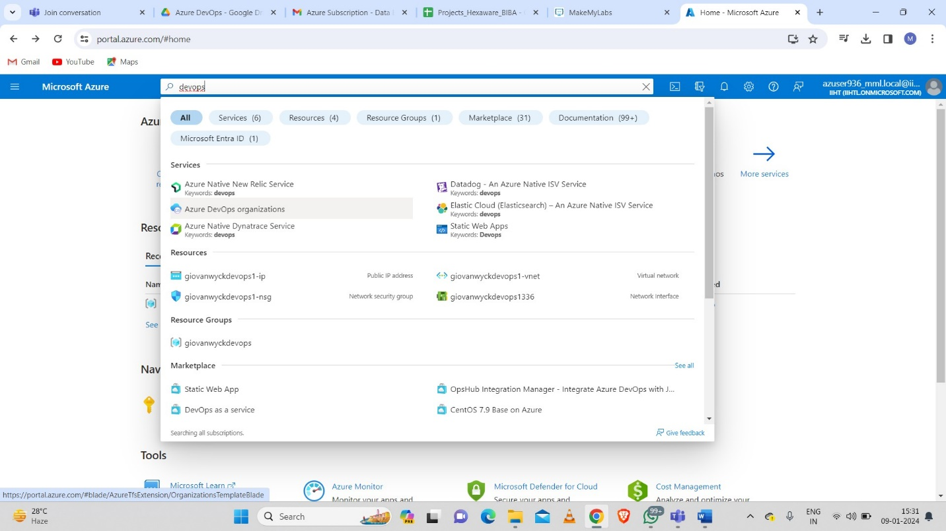

Then we need to add few more details like name, mail id, country to create an organization account and click on continue.

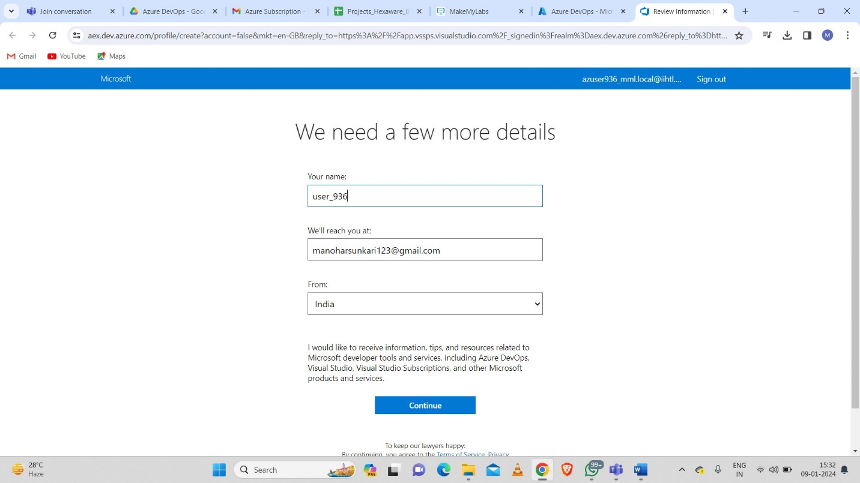

Now the dashboard will be opened to create a new organization.

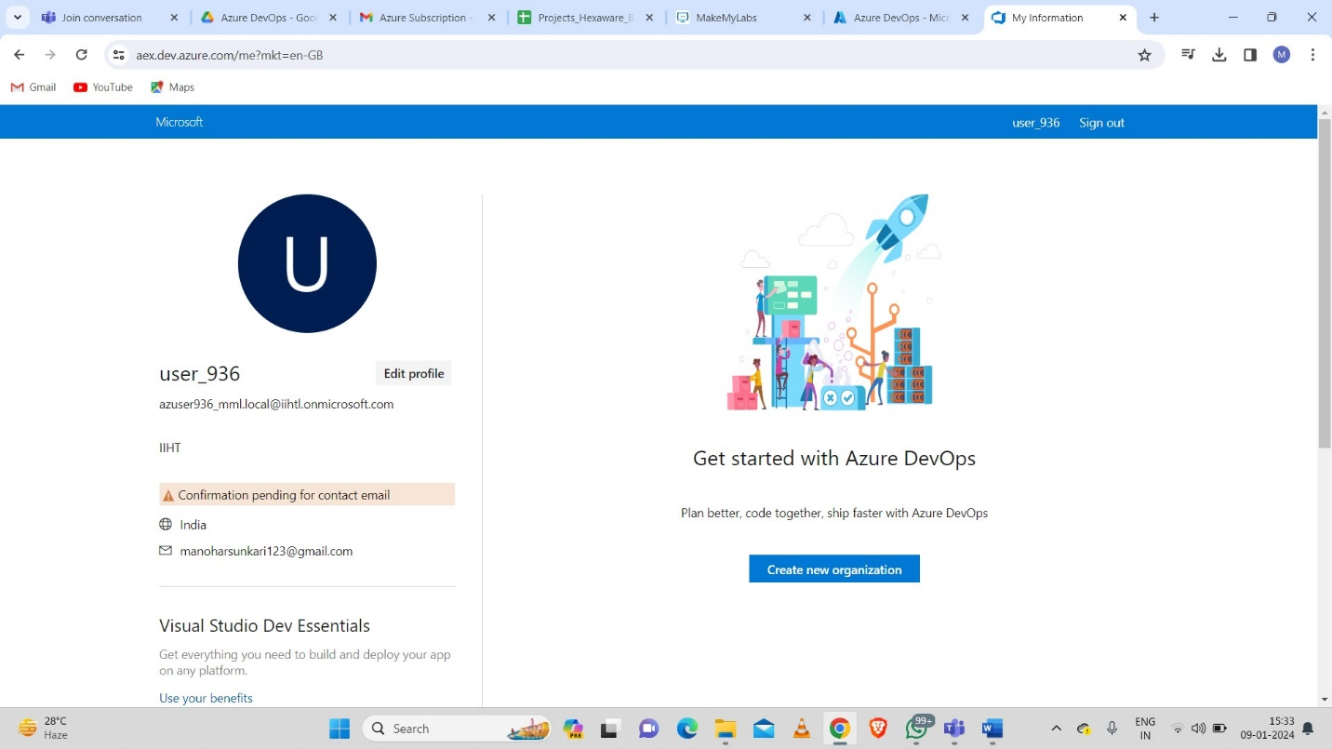

After clicking on create new organization then we need to give name of azure devops organization and we need to select the area to host.

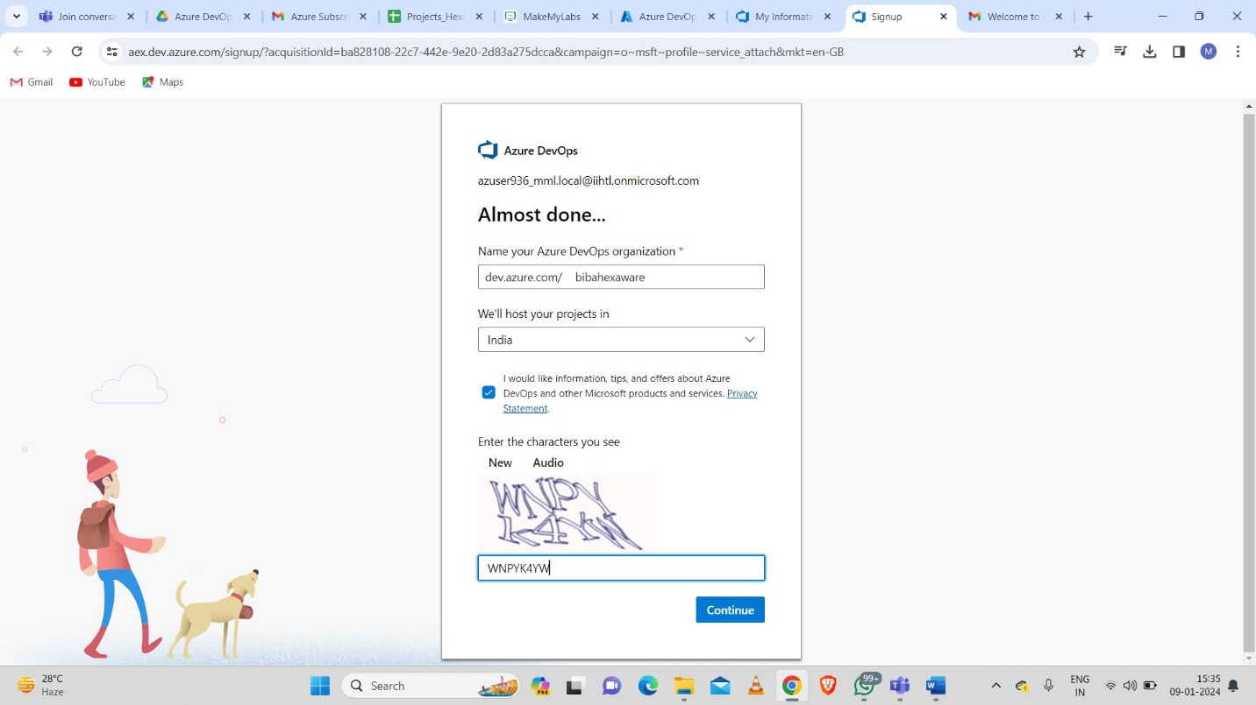

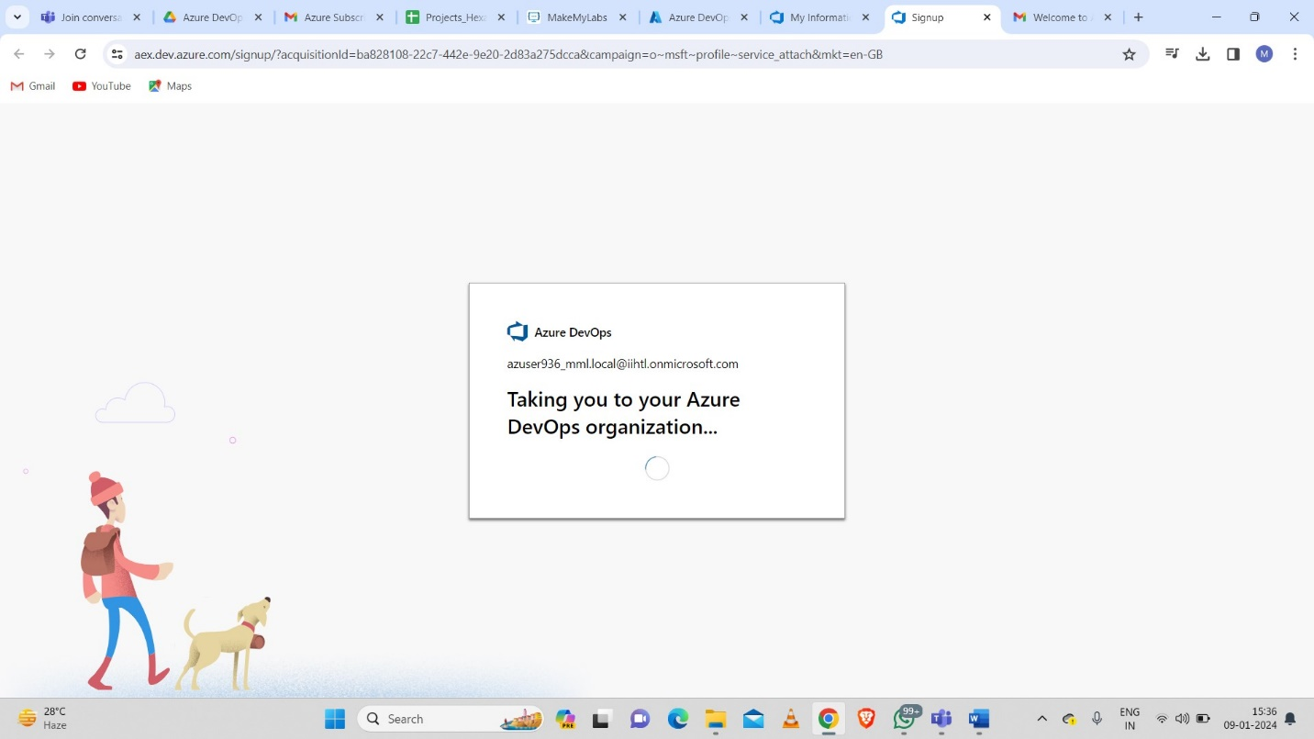

The dashboard will be opened to create a new project.

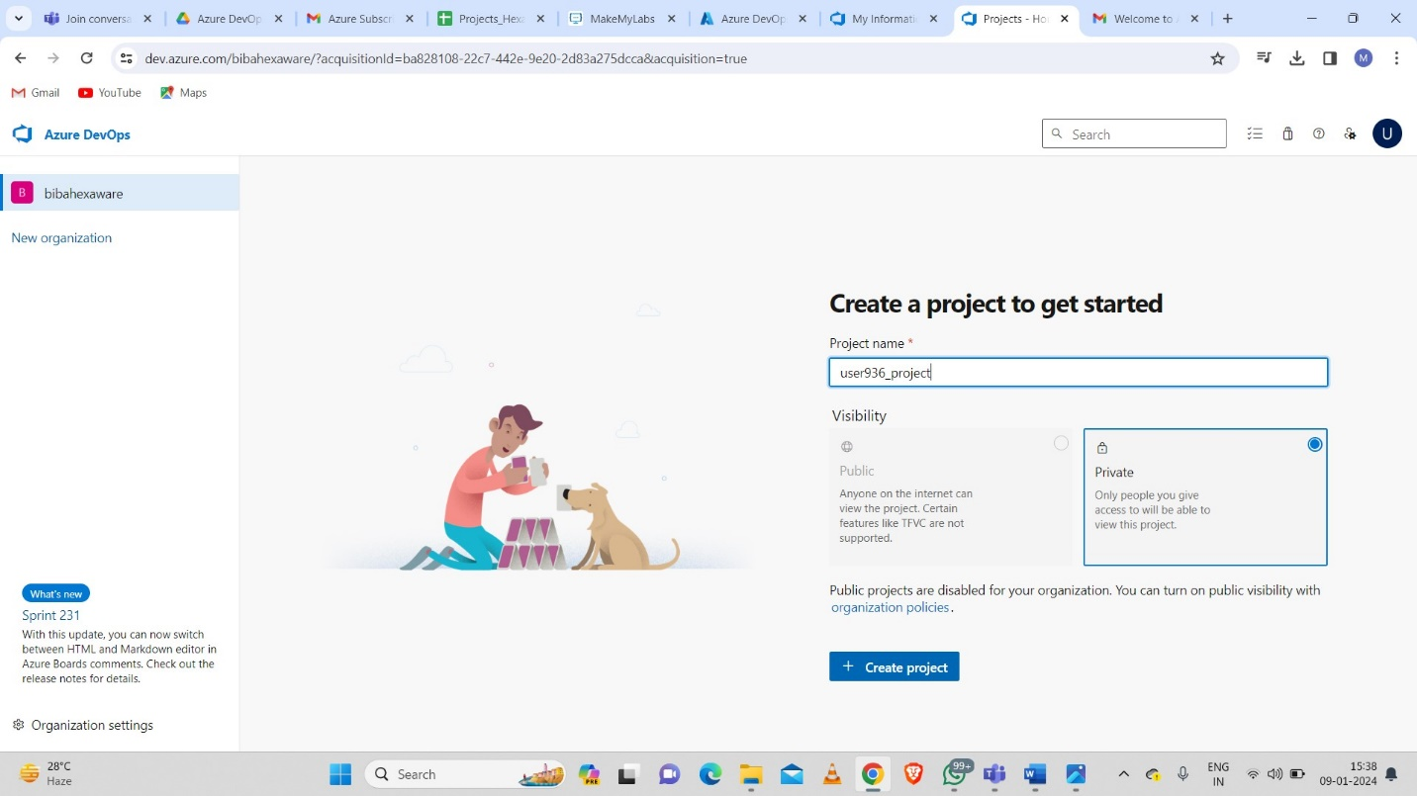

After creating the project, we will redirected to home page.

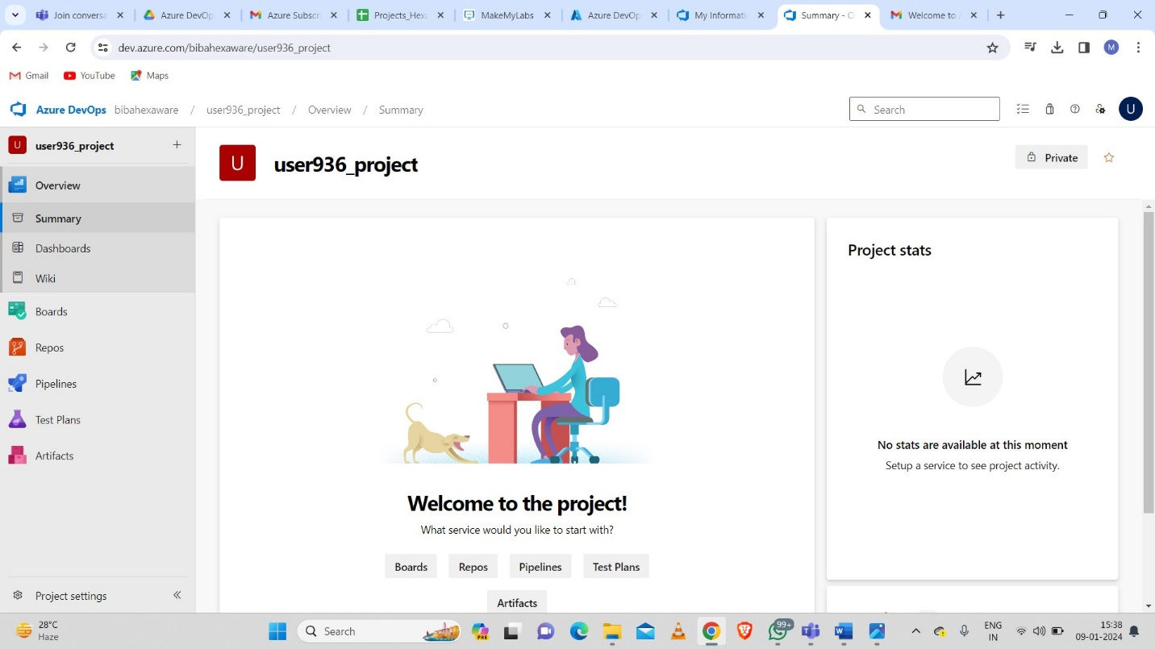

Now we need to open Repos and then create a new repository.

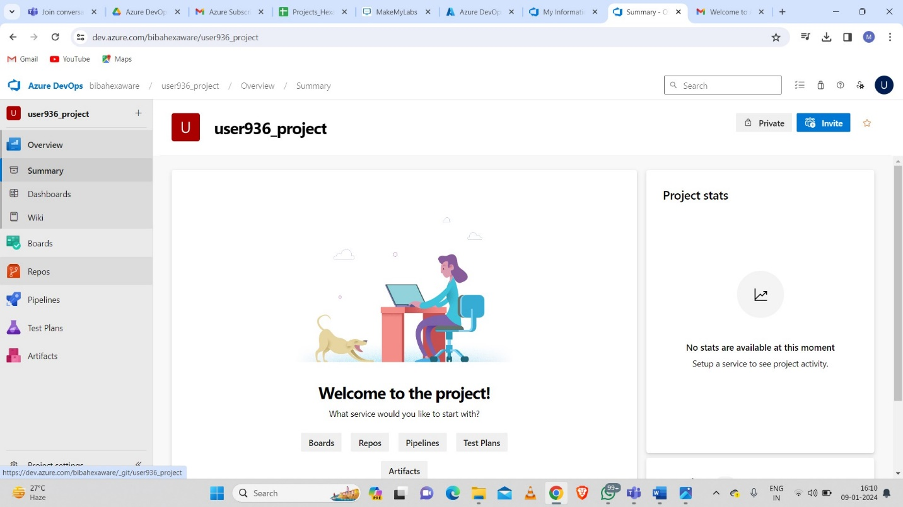

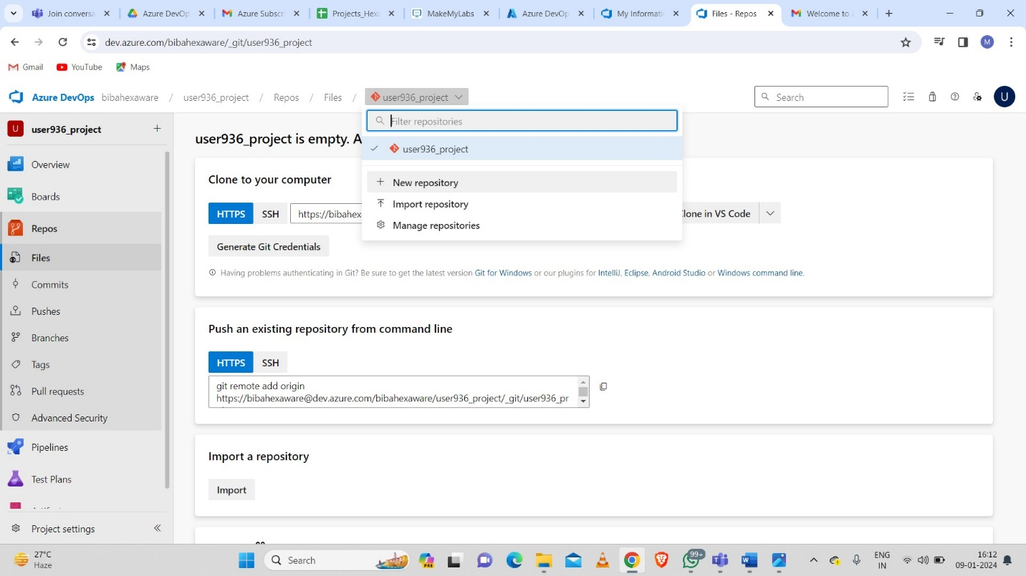

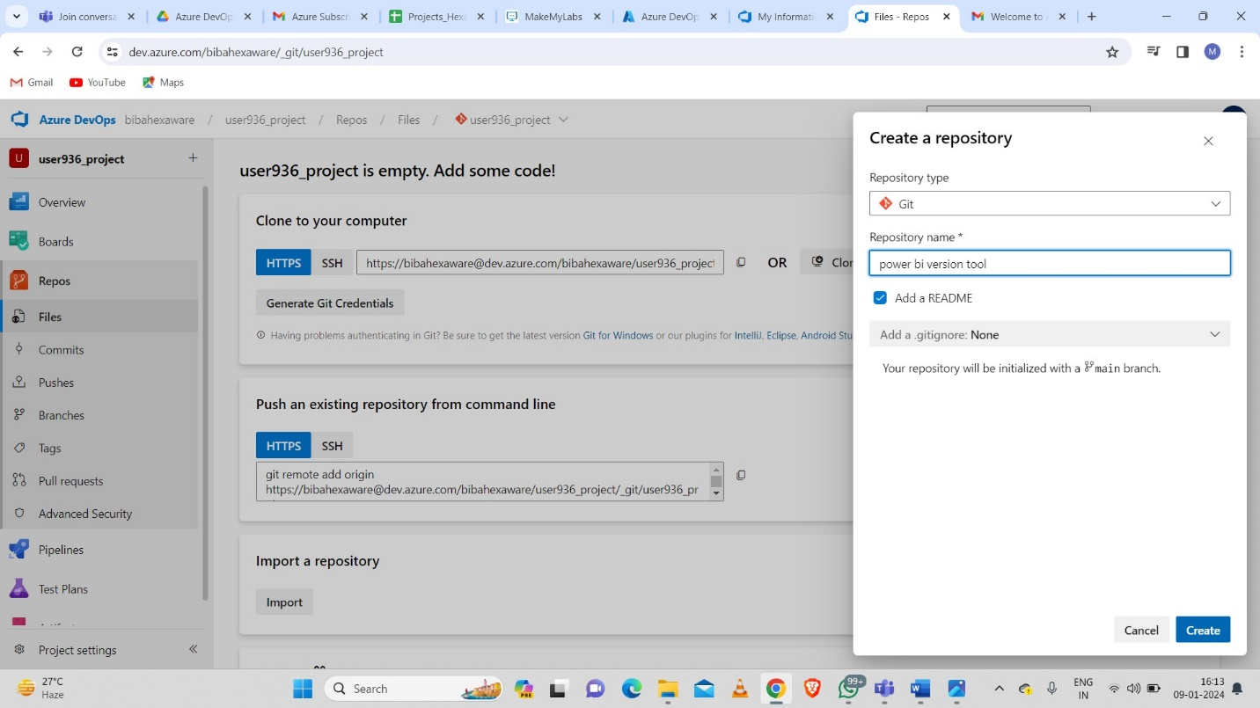

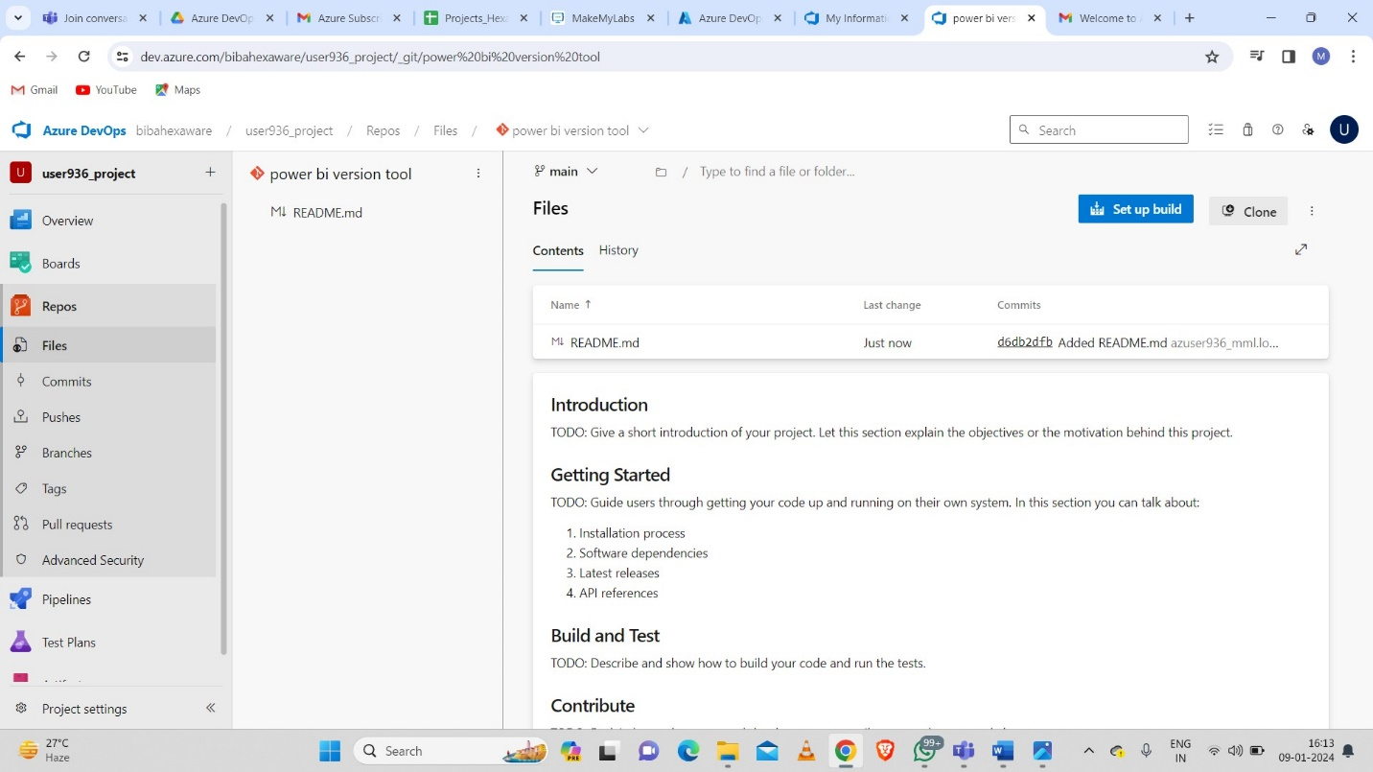

And also we can clone the repository using some git commands.

**Git commands:**

* Git init
* Git add .
* Git commit
* Git push origin main